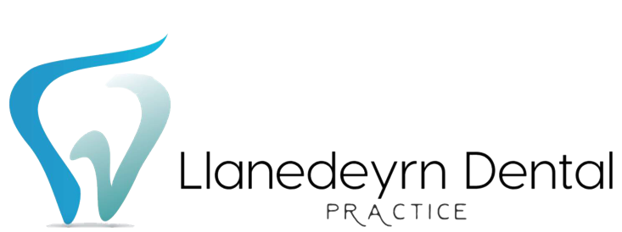

*If you have answered “YES” to any of the above questions please DO NOT attend Llanedeyrn Dental Practice before discussing with one of the clinicians over the phone – 029 2073 4404 – Many thanks.*

YES/ NO

7. Have you been notified by NHS Test & Trace in the last 14 days that you are a contact of a person who has tested positive for COVID-19 and you do not live with that person?

6. Do you live with someone who has either tested positive for COVID-19 OR had symptoms of COVID-19 in the last 14 days.

YES/ NO

New, continuous cough. YES/NO

High temperature or fever. YES/NO

Loss of, or change in, sense of smell or taste YES/NO

4. Are you waiting for a COVID-19 test or the results?

5. Do you have any of the following symptoms:

YES/ NO

COVID-19 RISK ASSESSMENT FORM

1. Full Name

2. Date of Birth

YES/ NO

3. Have you tested positive for COVID-19 in the last 7 days?

__________________________________________________________

__________________________________________________________